



Essay / Assignment Title: Exploring Artificial Intelligence Trends Across Sectors through Tableau Visualizations
Programme title: Visualization and Storytelling using Tableau
Name: Naga Surendera Babu Aravapalli
Year: 2026

CONTENTS

Table of Contents
CONTENTS 2
Table of Contents 2
List of Tables: - 4
List of Figures: - 4
1. INTRODUCTION 6
1.1 Business Context: - 6
1.2 Objective: - 6
1.3 Problem Statement: - 6
2. Data Selection and Preparation 7
2.1 Dataset selection and preparation: - 7
2.2 Description of Variables: - 7
3. Artefact Creation in Tableau 9
3.1 AI Jobs by Industry: - 9
3.2 Salary distribution by Industry: - 10
3.3 AI Jobs by Experience Level: - 11
3.4 Geographic distribution of AI jobs: - 11
3.5 AI Jobs growth Trend: - 12
3.6 Company Size V/s Salary: - 13
3.7 AI Jobs percentage by Experience level: - 13
4. Dashboard Design 15
4.1 Dashboard-1: - 15
4.2 Dashboard-2: - 16
4.3 Story Telling: - 17
5. Excel Component 19
5.1 Industry wise AI Jobs & Average Salary: - 19
5.2 AI Jobs Demand and Average Salary by Industry: - 20
6. CONCLUDING REMARKS 21
6.1 Findings: - 21
6.2 Recommendations: - 21
BIBLIOGRAPHY 23
APPENDIX (if necessary) 24

List of Tables: -
Table 1 Description of Variables 8
Table 2 Industry wise AI Jobs & Average Salary 19

List of Figures: -
Figure 1 AI Jobs by Industry 9
Figure 2 Salary distribution by Industry 10
Figure 3 AI Jobs by Experience Level 11
Figure 4 Geographic distribution of AI Jobs 11
Figure 5 AI Jobs growth Trend 12
Figure 6 Company size V/s Salary 13
Figure 7 AI Jobs percentage by Experience level 13
Figure 8 Dashboard - 1 15
Figure 9 Dashboard - 2 16
Figure 10 Story Telling_Dashboard-1 17
Figure 11 Story Telling_Dashboard-2 18
Figure 12 Excel tool _AI Jobs Demand and Average Salary by Industry 20

Statement of compliance with academic ethics and the avoidance of plagiarism

I honestly declare that this dissertation is entirely my own work and none of its part has been copied from printed or electronic sources, translated from foreign sources and reproduced from essays of other researchers or students. Wherever I have been based on ideas or other people texts I clearly declare it through the good use of references following academic ethics.
(In the case that is proved that part of the essay does not constitute an original work, but a copy of an already published essay or from another source, the student will be expelled permanently from the program).

Name and Surname (Capital letters): NAGA SURENDERA BABU ARAVAPALLI
Date: 21/02/2026

1. INTRODUCTION

1.1 Business Context: -
Artificial Intelligence (AI) has a wide impact on the job market of various Industries. In the modern world, the preference for AI has been increasing, which has increased the demand for AI professionals across every industry, such as Automotive, Consulting, Energy, Gaming, Real Estate, Technology, Finance, Retail, Banking, Education, Media, Telecommunication, and Transportation. This study used the dataset from the online website Kaggle. Organisations are offering high salaries to maintain the huge volume of business transactions. It helps the management with decision-making. The Tableau visualisation tool is used to prepare visualisation sheets, interactive dashboards and story board. An Excel component pivot table and chart are used to make advanced visualisation. The AI jobs offered by different companies globally have different requirements, salaries & roles.

1.2 Objective: -
- The main objective is to analyze the job market among various sectors.
- Salary distribution based on experience level.
- To visualize the dashboard using advanced excel component.

1.3 Problem Statement: -
Prepare a set of visualizations to explore how Artificial Intelligence is used across various industries of Job Market and its impact. The visualization has to be used with Tableau or Excel.

2. Data Selection and Preparation

2.1 Dataset selection and preparation: -
The Dataset has selected from the Kaggle website (https://www.kaggle.com/datasets/sahilislam007/ai-impact-on-job-market-20242030) and the dataset format is csv. The data relevant to the use of artificial intelligence in the job market was described for different segmentations, including visualisations to demonstrate the outcomes briefly.
The dataset was cleaned with excel before uploading into Tableau. Blank or incomplete rows were removed. Data type contained different types such as String, Numerical Date/Year & Geographical locations. Created calculated field for salary category [1] and various measure names are Remote Ratio, Salary (USD), Years of experience and Benefit score.

2.2 Description of Variables: -
Description of variables (i.e Columns) in the Dataset which consists of 19 variables.
Sl.No. | Variables | Description
1 | job_id | Unique Identification number of each Job
2 | job_title | Designation of a Job/Position
3 | salary_usd | Amount of Salary in US Dollars
4 | salary_currency | Payable currency of Salary
5 | experience_level | Type of experience like ENTRY, MIDDLE, EXPERIENCED, SENIOR
6 | employment_type | Different types of Employment
7 | company_location | Country of each Company
8 | company_size | Size of each Company: Small, Medium, & Large
9 | employee_residence | Country of each employee
10 | remote_ratio | Remote work in percentage either 50% or 100% or 0 %
11 | required_skills | Skills required to perform/apply for a job
12 | education_required | Education is needed to apply for a job
13 | years_experience | Experience in years suitable for the job
14 | industry | Relevant sector name
15 | posting_date | Date of a job post announced
16 | application_deadline | Due date of an application to be submitted
17 | job_description_length | Roles and Duties of a job
18 | benefits_score | Score of benefits provided
19 | company name | Name of a Company
Table 1 Description of Variables

3. Artefact Creation in Tableau

3.1 AI Jobs by Industry: -
These visuals reflect the industry-wide Artificial Intelligence Jobs, where the dataset contains 15 different industries.
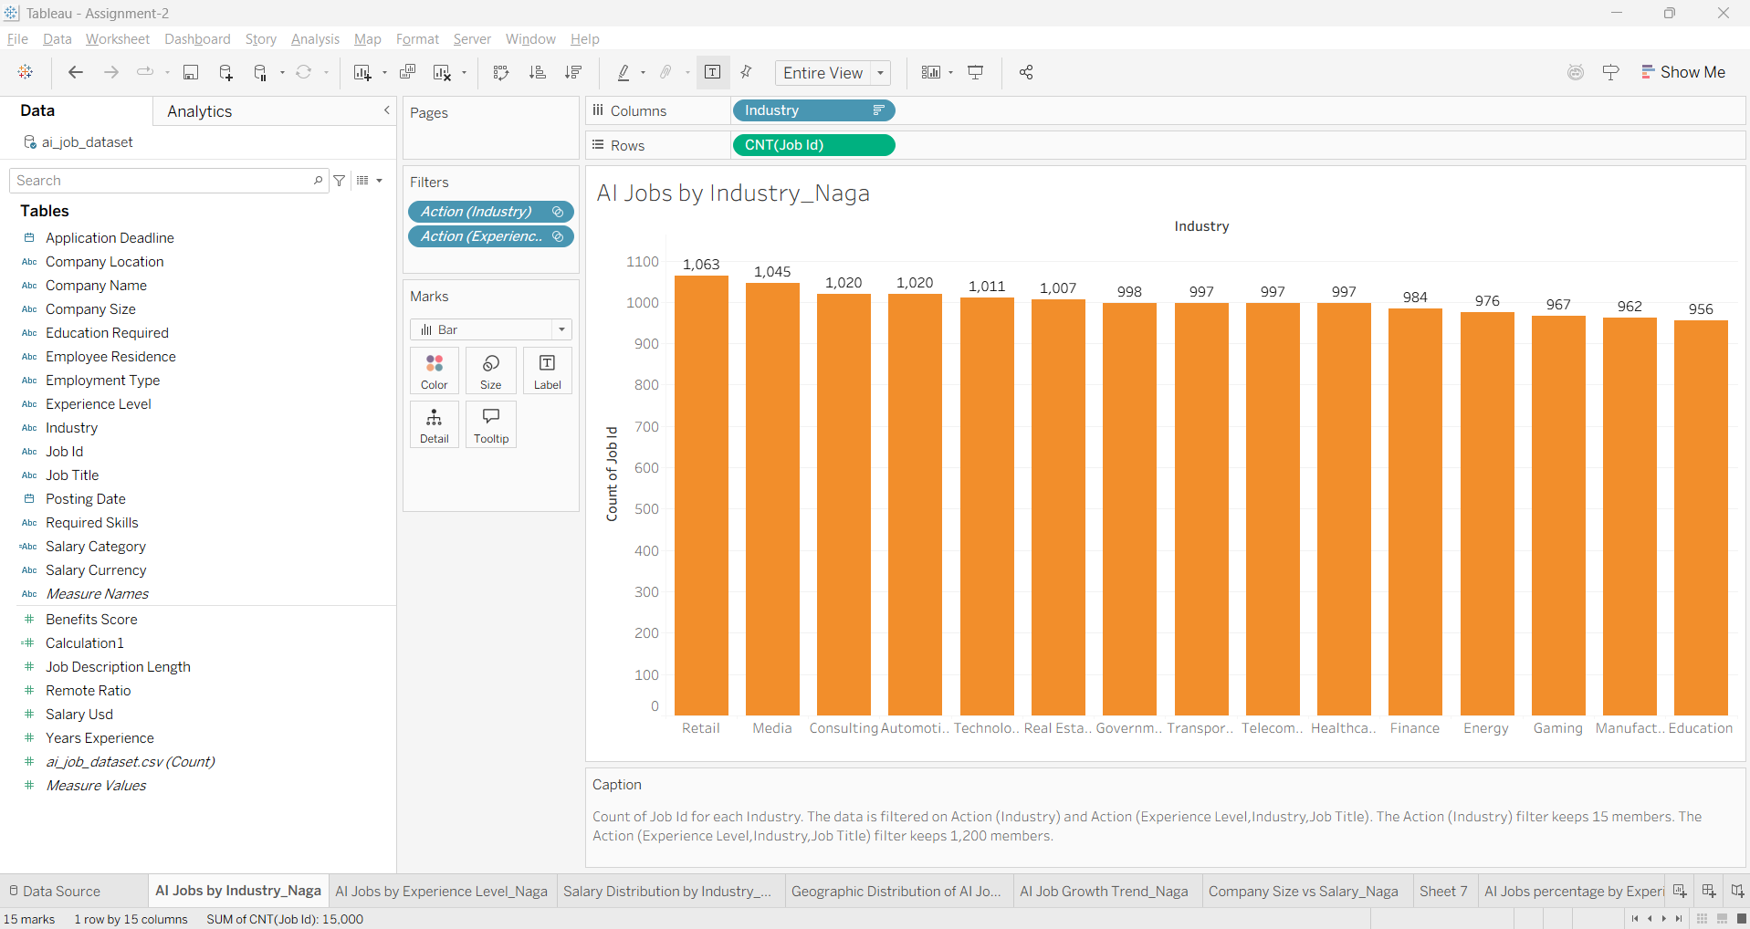
Figure 1 AI Jobs by Industry

Observations: -
- The retail sector is posting the highest number of AI jobs, 1063, whereas Education is the least with 956 jobs.
- Three industries have an equal number of AI jobs, 997, which is close to the Government industry. The Government industry has 998 jobs.

3.2 Salary distribution by Industry: -
Salary has distributed across all the 15 industries [3] and applied Median, IQR (Inter Quartile Range) anlaysis. Considered 95% Confidence intervals for both average and median.
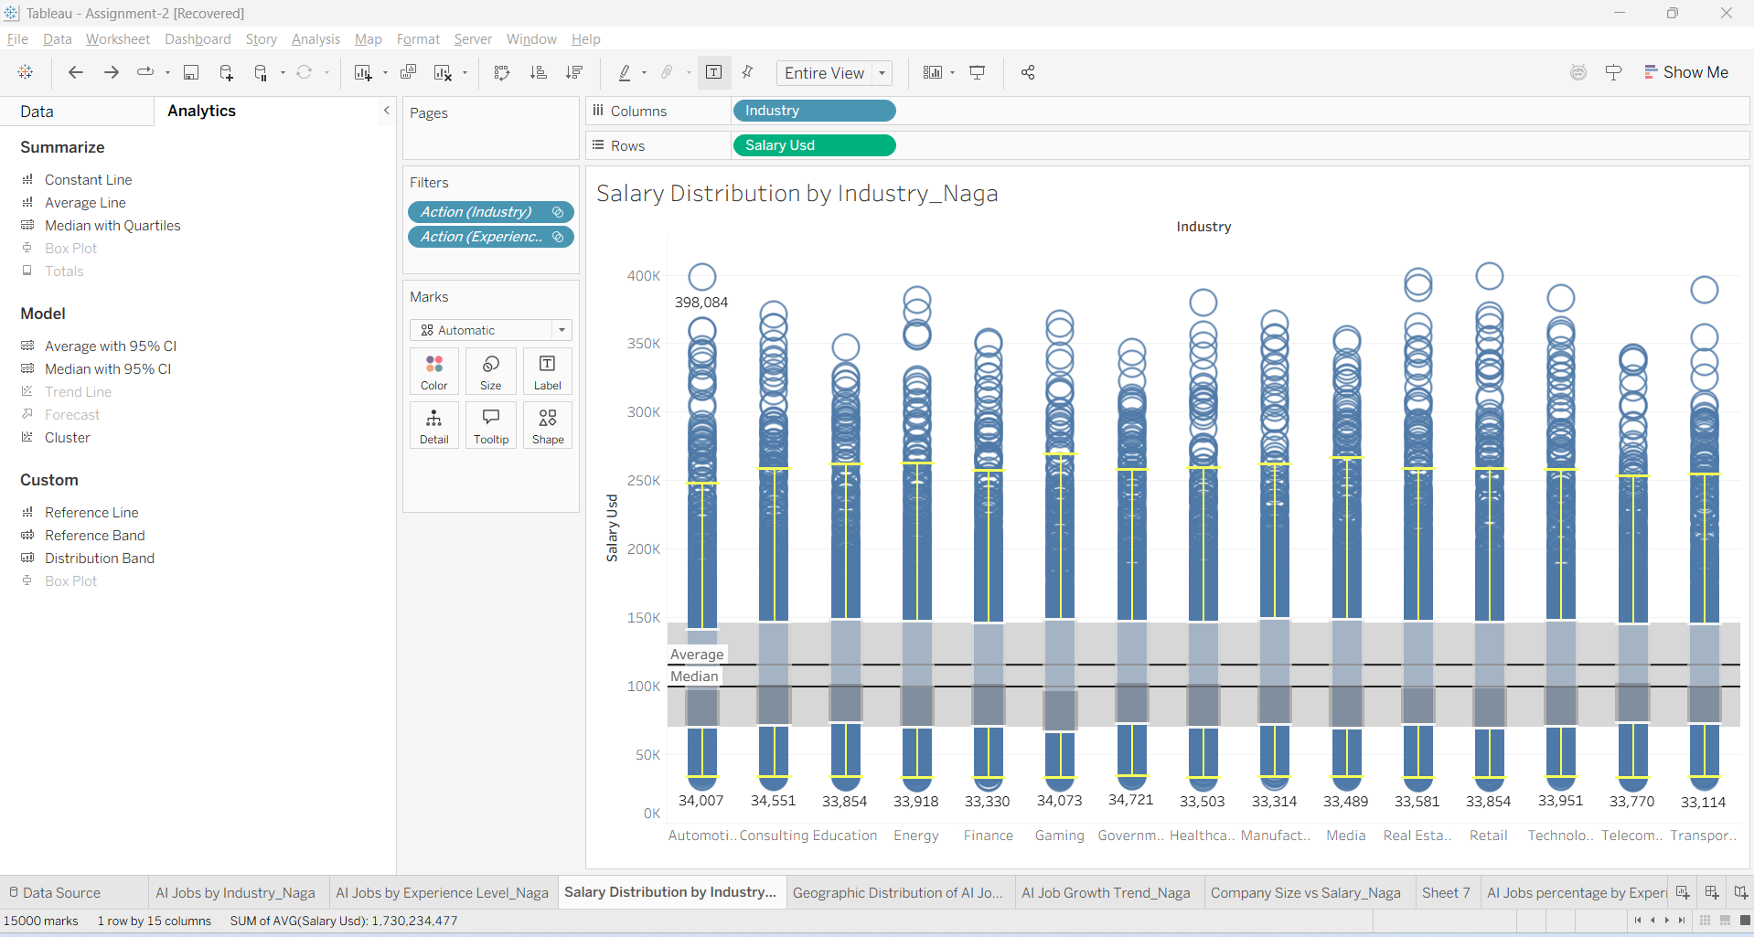
Figure 2 Salary distribution by Industry

Observations: -
- The highest amount of salary outliers indicating for these industries Automotive, Real Estate, Retail and Transport.
- Future Systems company of Automotive industry offered highest salary in USD 398,084 for AI Architect job that increases budget. Requirements are Experience level-EX, employment_type – CT, Company Location – Switzerland & Company size – L, Skills required - Python, Linux, Tableau, TensorFlow.
- Average salary of 95% Confidence interval is $ 116,313 and Median salary of 95% Confidence interval is 100,896.
- The lower whiskers appear the salary range between 30k – 40k whereas upper whiskers having relatively large variation across all the industries.

3.3 AI Jobs by Experience Level: -
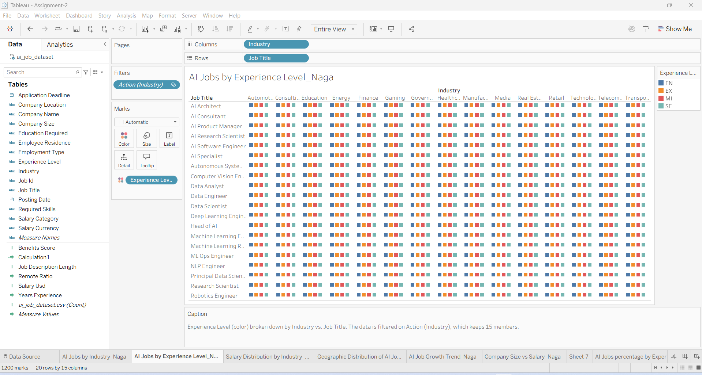
Figure 3 AI Jobs by Experience Level

3.4 Geographic distribution of AI jobs: -
The distribution of 20 job titles geographically across all the countries. It describe the number of positions available for each job designation.
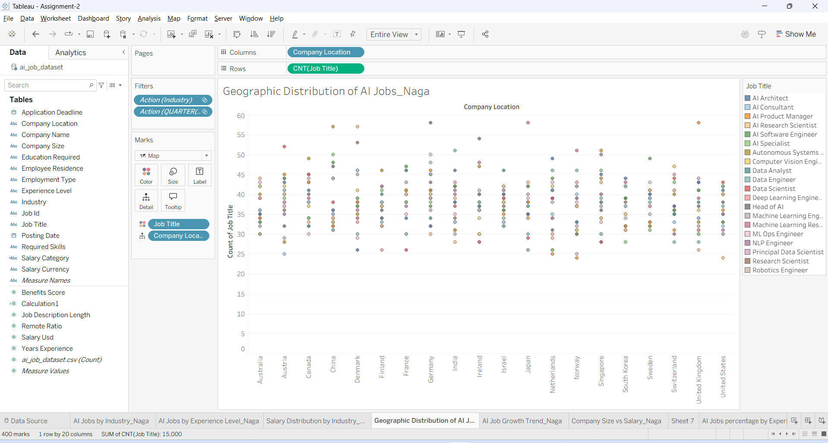
Figure 4 Geographic distribution of AI Jobs

Observations: -
Top level range 55-60 : Higher number of these jobs Autonomous systems engineer (China-57), AI Research Scientist (Denmark-57), Head of AI (Germany-58), Machine Learning Researcher (Japan-58) & AI Product Manager (United Kingdom-58).
Lower range 20 – 25: Some countries offering less number of less number of jobs like AI Consultant (Austria-25), AI Product manager (Netherlands-25), Robotics Engineer & AI Product Manager (Norway-25) & Computer vision engineer (United States-24).

3.5 AI Jobs growth Trend: -
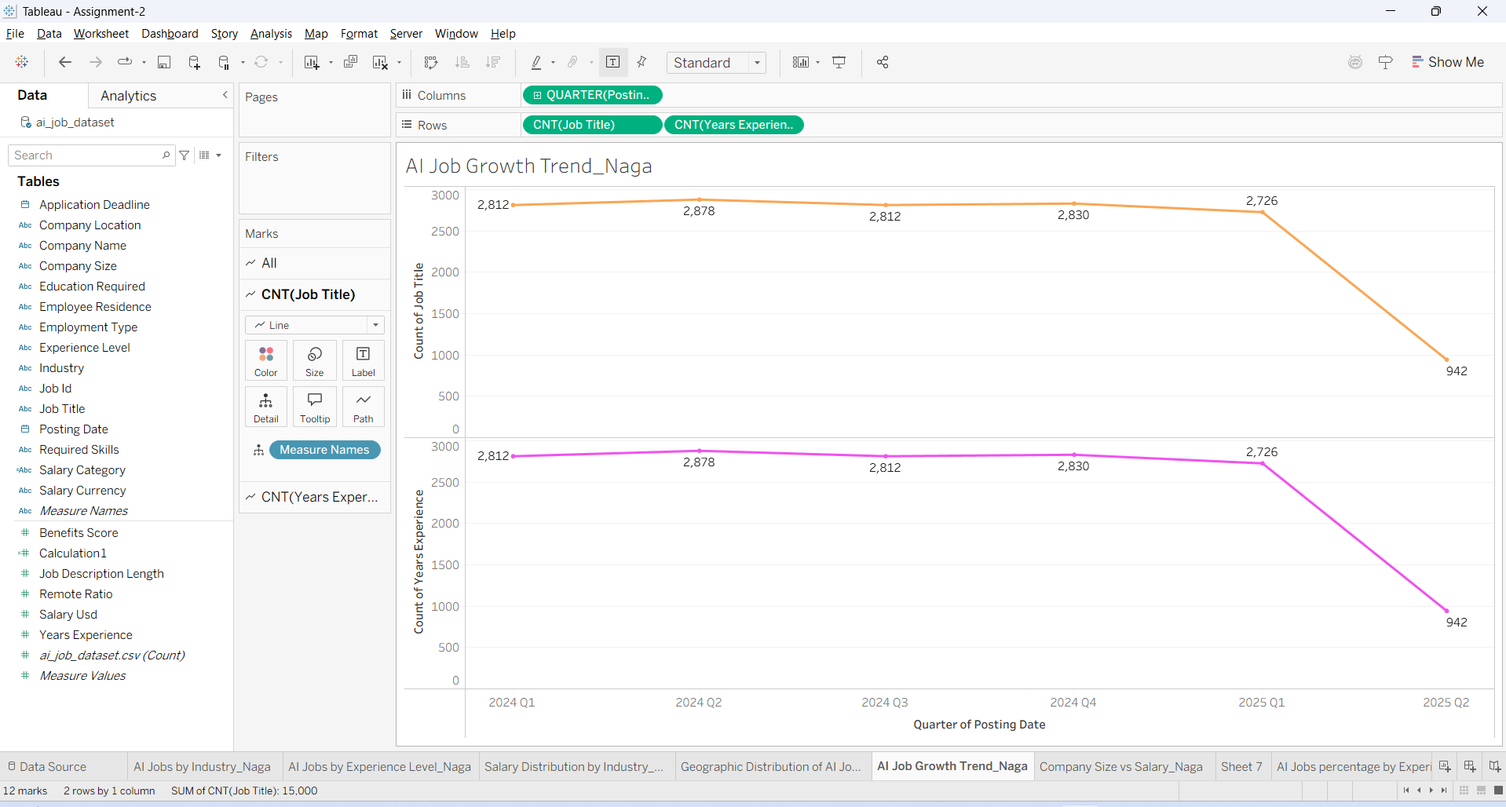
Figure 5 AI Jobs growth Trend

3.6 Company Size V/s Salary: -
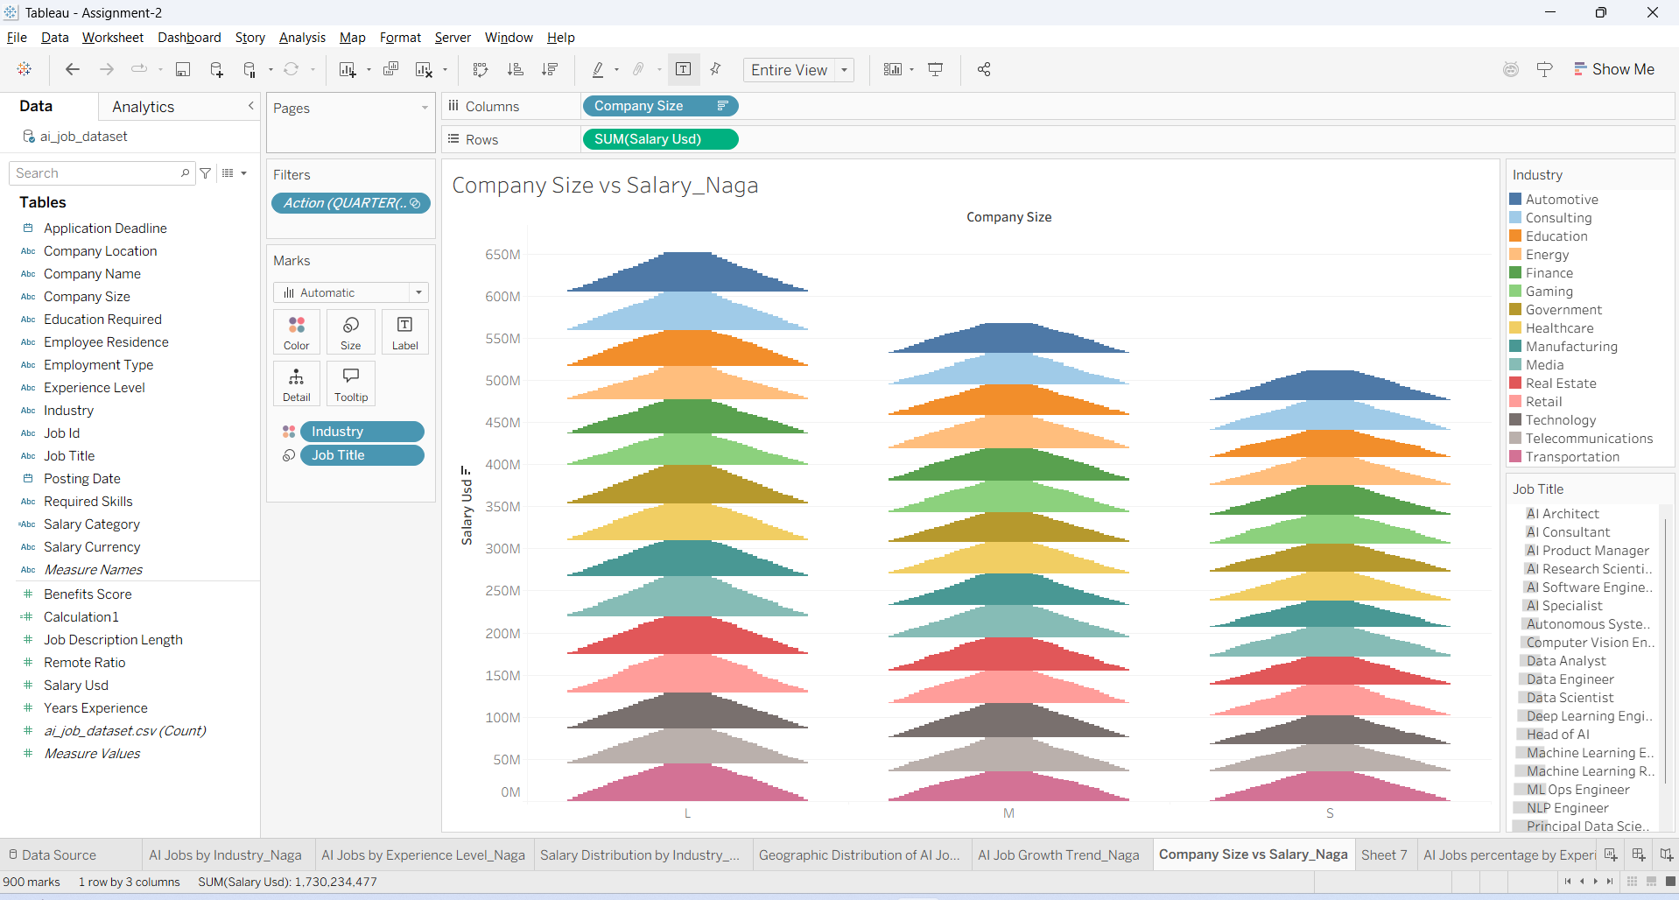
Figure 6 Company size V/s Salary

3.7 AI Jobs percentage by Experience level: -
It shows the number of jobs based on experience level.
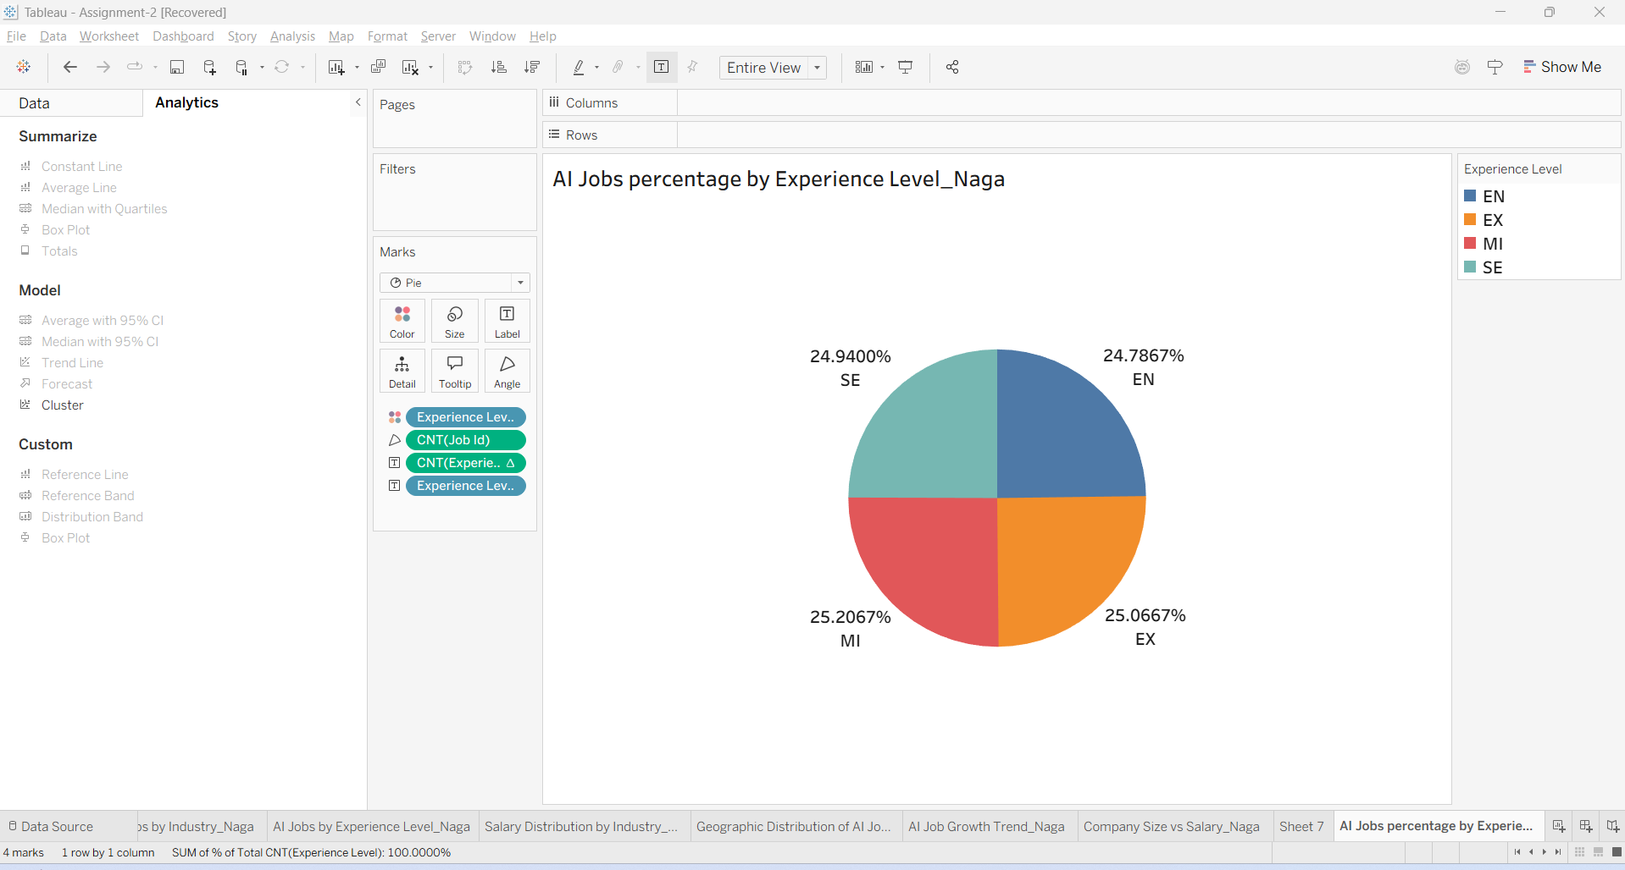
Figure 7 AI Jobs percentage by Experience level
Observations: -
- All the experience levels distributed almost same with smaller difference.
- Experience level – MI persons have more AI jobs comparatively with others whereas Entry Level – EN has lower jobs.

4. Dashboard Design

This chapter is relating to Dashboards visualization that has prepared with Tableau visualization tool.

4.1 Dashboard-1: -
This Dashboard relevant to AI Jobs by Industry, by Experience level and Salary distribution by Industry wise.
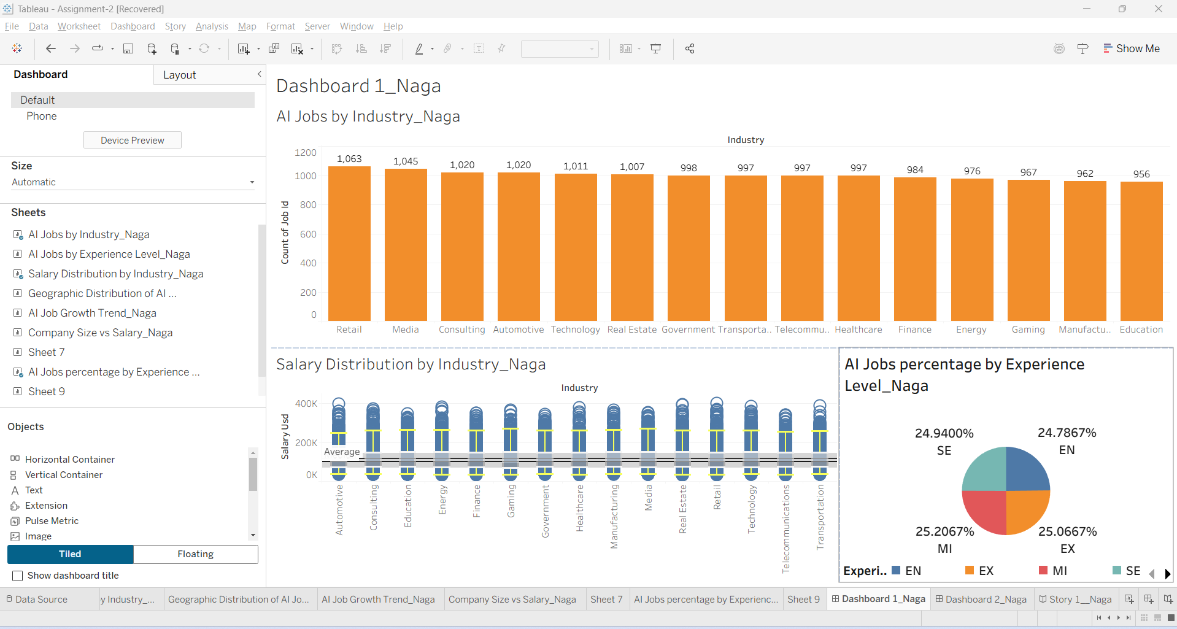
Figure 8 Dashboard - 1

4.2 Dashboard-2: -
Dashboard 2 is summary of AI Job growth trend,
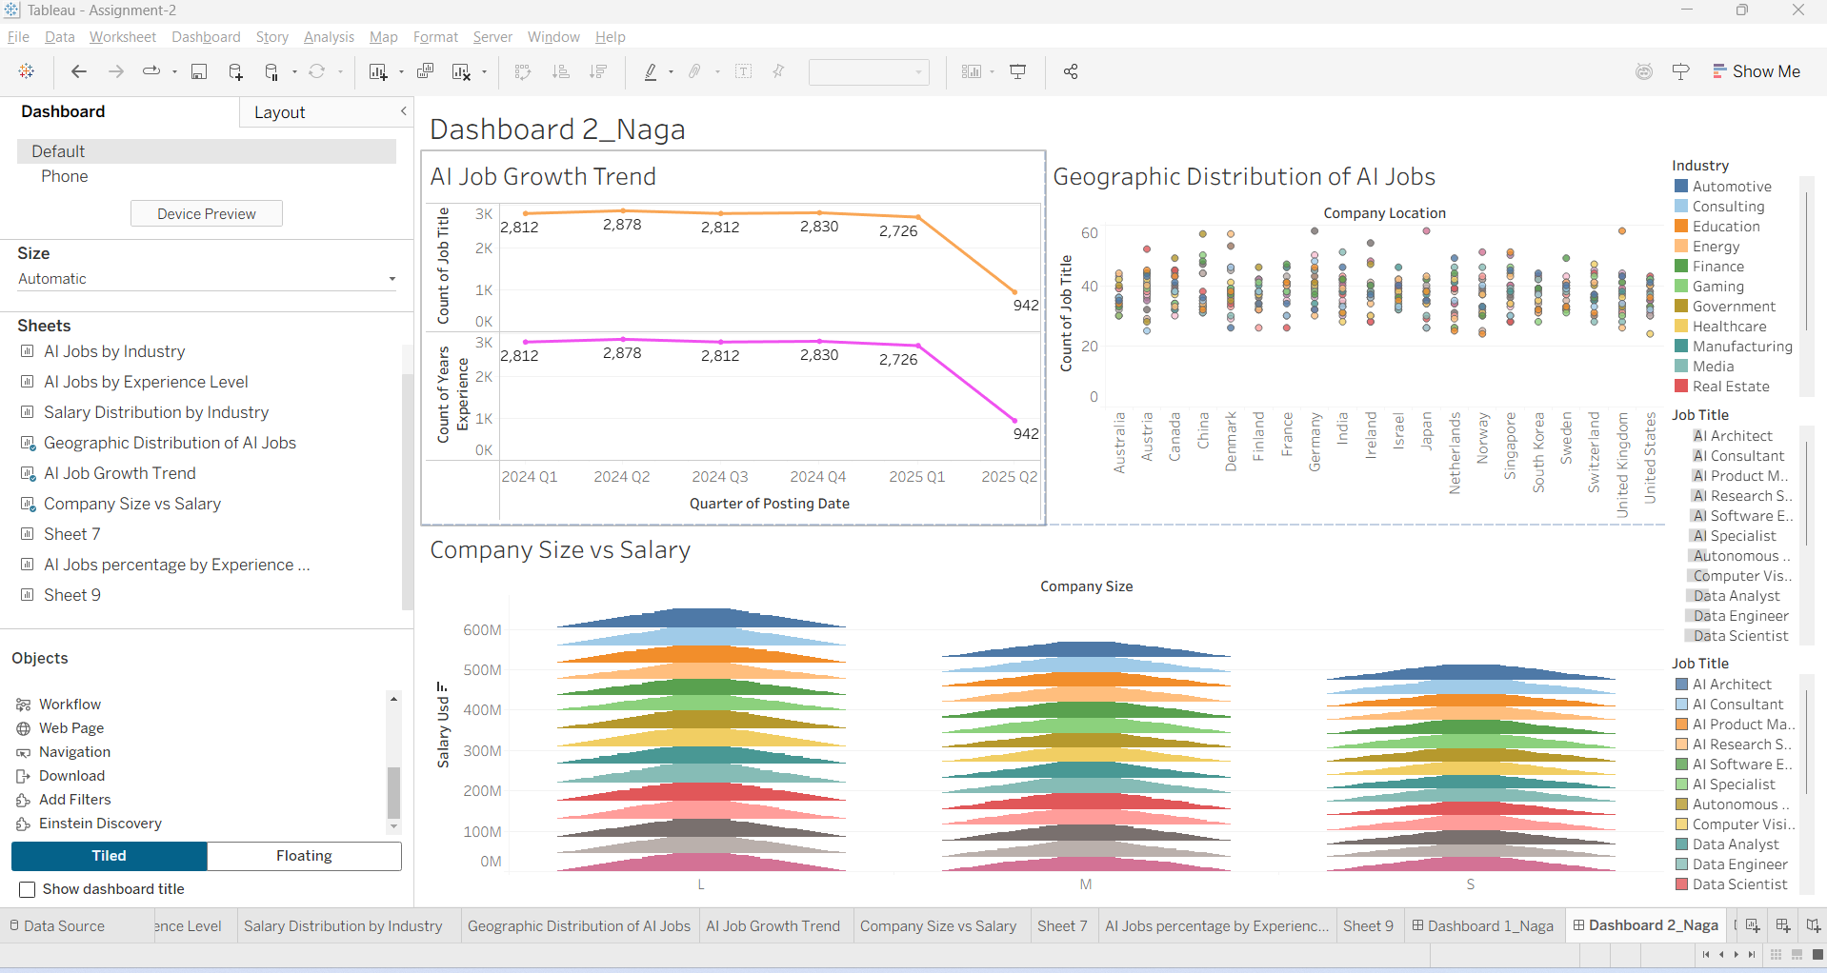
Figure 9 Dashboard - 2

Observations: -
- Median salary ranges between 100k - 150k instead of very high salary outliers. Box plot for retail shows IQR (Inter Quartile Range) and Multiple high value outliers close to 400K USD. It includes all kinds of experienced level jobs.
- Retail sector aggressively adopting the AI Technology across the industry for automation, prediction of business data analytics, digital transformation of data.
- Mostly compensation is driven by technical experts.

4.3 Story Telling: -
Story telling is a summarized insights from the Dashboard -1 and Dashboard-2.
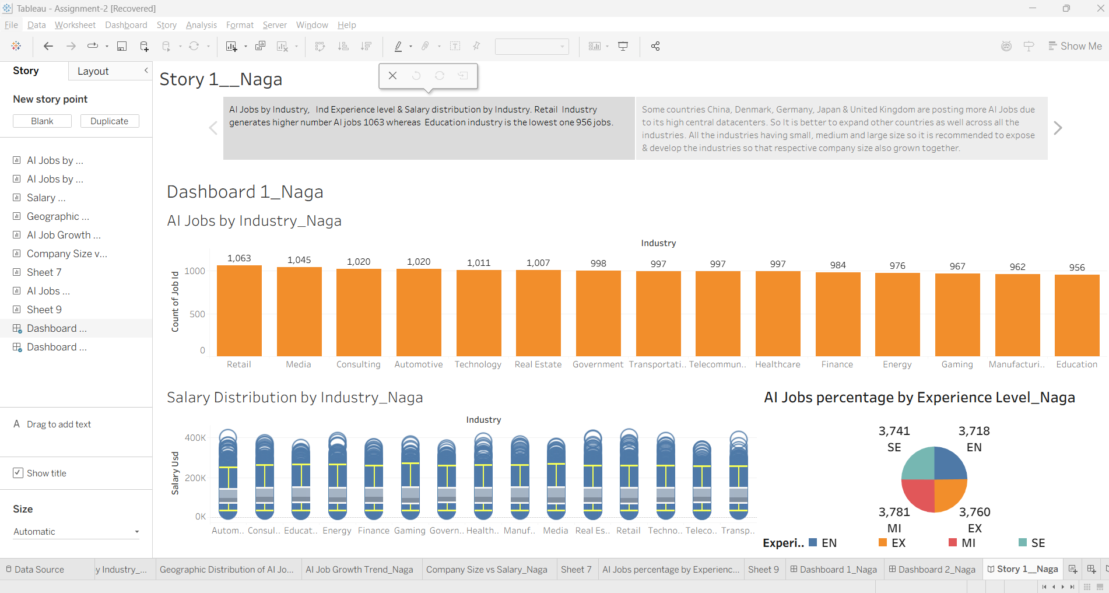
Figure 10 Story Telling_Dashboard-1

Findings & Suggessions: -
- AI Jobs by Industry, Ind Experience level & Salary distribution by Industry [6].
- Retail Industry generates higher number AI jobs 1063 whereas Education industry is the lowest one 956 jobs.

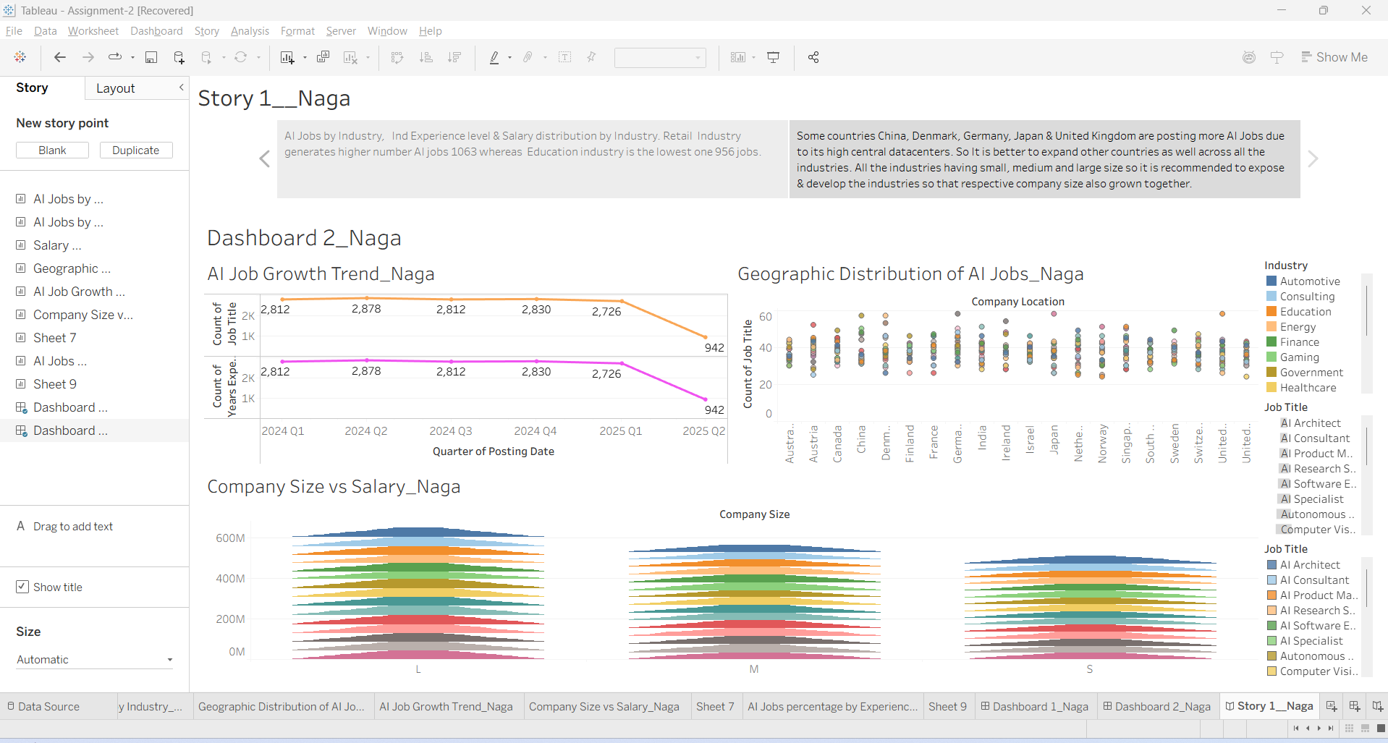
Figure 11 Story Telling_Dashboard-2
Findings and Recommendations: -
- It is better to expand other countries as well across all the industries.
- All the industries having small, medium and large size so it is recommended to expose & develop the industries so that respective company size also grown together.

5. Excel Component

This analysis made for every industry by comparing Job postings with Average salary (USD) and used Excel tool.
This helps to control the personnel budget/investment for each job in any size of company.

5.1 Industry wise AI Jobs & Average Salary: -
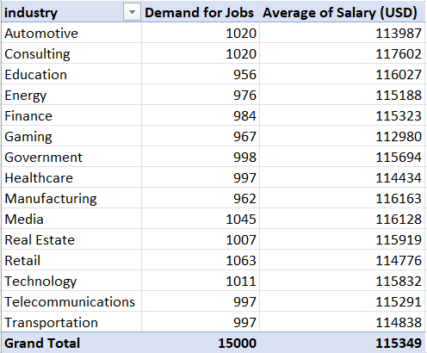
Table 2 Industry wise Average Salary & AI Jobs

5.2 AI Jobs Demand and Average Salary by Industry: -
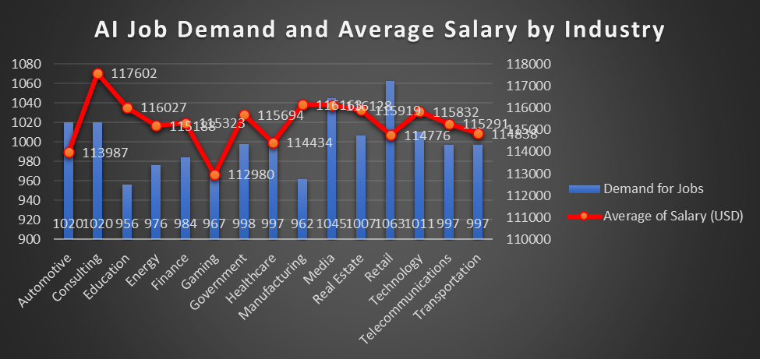
Figure 12 Excel tool _AI Jobs Demand and Average Salary by Industry
Observations: -
- Manufacturing & Education industries occupied with a smaller number of jobs but they are offering higher average salaries.
- Retail sector has many job positions with low packages instead of high salaries.
- These two industries Automotive & Consulting same number of jobs in different sectors. However, Consulting jobs offering better salaries than Automotive industry.
- Overall, it least averages salaries across entire Gaming industry. It does not require too many literacy but it depends on more creativity skills.
- Healthcare industry maintaining the Jobs and salaries proportionately. It is the best sector because both are in equal proportionate share.
- Average salaries trend in red color and industrial bars with blue color.

6. CONCLUDING REMARKS

This study has successfully transformed the dataset in to interactive dashboards and useful insights.

6.1 Findings: -
- AI Job opportunities are more focused areas, such as Finance, Technology, Consulting and Retail. These industries are adopting Fastly to improve processes and minimise costs.
- An increase in experience level will offer higher salaries than those of entry-level employees. So, experts in AI Technology earns high salaries.
- According to the Geographical analysis most of the AI Job opportunities are in developed countries so it needs more infrastructure facilities to setup. It is very emerged across all the industries globally.
- AI jobs have two kinds of opportunities like onsite and remote basis. So organizations are attracting many professionals with these offers.

6.2 Recommendations: -
- AI Technology skills have to be improved during the education time. Companies need to train their employees on AI technology tools so it builds their career with high performance. They could become resources to the company growth.
- AI jobs are permitted to the after education finished. Hence, it is better to train students during the education to improve the awareness on AI tools. It helps them to capture job opportunities immediately after education. Also, it can increase education industrial growth tremendously.
- In real time companies have to give an option to utilize remote work that makes convenience to the employees. It can control the attrition rate and shortage of skilled resources in the job market. Global professionals also can attract to improve the productivity & value-added service.
- Research and development institutions require funds and permissions to cover various industries. So, Governments should encourage and allocate funds to the research institutions. It helps to automate the manual tasks across all the industries globally.
- Organizations required to move towards data privacy and cyber security that can control the cybercrimes.

BIBLIOGRAPHY

- Hung, C.C. and Lim, E.P., 2021. On aggregating salaries of occupations from job post and review data. IEEE Access, 9, pp.43422-43433.
- Yang, L. and Zhu, M., 2019, April. Review on the status and development trend of AI industry. In 2019 IEEE 4th International Conference on Cloud Computing and Big Data Analysis (ICCCBDA) (pp. 89-93). IEEE.
- Mamad, M. and Chichi, O., 2024, July. Towards a human-centred artificial intelligence in the age of industry 5.0: a cross-country analysis. In 2024 11th International Conference on Wireless Networks and Mobile Communications (WINCOM) (pp. 1-6). IEEE.
- Jha, R., Paliwal, G. and Jha, B.K., 2025, March. AI-powered resume builder: Enhancing job applications with artificial intelligence. In 2025 3rd International Conference on Disruptive Technologies (ICDT) (pp. 1655-1660). IEEE.
- Momenikorbekandi, A. and Abbod, M.F., 2023. A novel metaheuristic hybrid parthenogenetic algorithm for job shop scheduling problems: applying an optimization model. IEEE Access, 11, pp.56027-56045.
- Ashrafi, S., Majidi, B., Akhtarkavan, E. and Hajiagha, S.H.R., 2023. Efficient resume-based re-education for career recommendation in rapidly evolving job markets. IEEE access, 11, pp.124350-124367.

APPENDIX (if necessary)

Source file link: - https://www.kaggle.com/datasets/sahilislam007/ai-impact-on-job-market-20242030

